How do Yandeks.Probki

Yandex shows users a picture of the traffic congestion. For this service collects data from various sources on the streets of congestion, analyzes it and displays On Yandex.Maps. In most large cities where traffic jams - a serious problem, not just a nuisance, the service calculates the score jams - the average level of congestion. To understand how it works Yandeks.Probki, consider all the way - from the actual traffic situation on the road to its image in the service. service technology is designed so that the traffic information is collected including the users themselves. That is to say that drivers are helping drivers to avoid traffic jams.

**data Sources**

To visualize what we are - an accident on the boulevard in front of Strastnom Petrovka (small and without sacrifices). His appearance, we blocked, for example, two rows of the existing three. Motorists who moved in our ranks, we have to go around, and drivers are moved to the third row - skip making the rounds. Some of them - users and applications Yandex Yandeks.Navigator and their mobile devices is transmitted Yandeks.Probki data on driving. As users of these machines closer to our accident their speed will be reduced, and the device will start to "inform" the service of the mash.

To participate in the data collection, motorists are required: internet access phone or tablet with a GPS-receiver and installed on the device or application Yandeks.Navigator Yandex enabled "to report traffic jams" mode. Every few seconds, the device transmits its geographic coordinates, direction and speed of the computer system Yandex.Probki. All data are impersonal, ie not contain any information about the user or his car. Then, the program analyzer builds a single traffic route with information about its speed of passage - a track. Tracks come not only from private drivers, but also from vehicles of partner companies Yandex (organizations with a large fleet of vehicles plying on the city).

In addition to its coordinates motorists can report service additional information about accidents, repairs or other road troubles. For example, some conscious driver, see our accident, he warned him of other motorists by putting the appropriate point in the mobile Yandex.Maps.

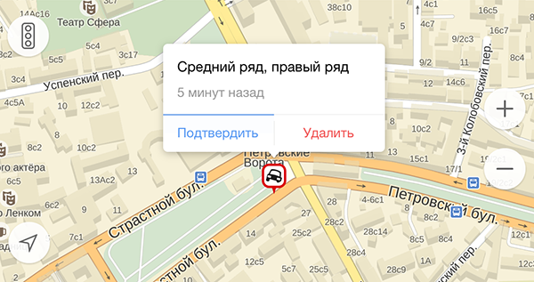

**tracks Processing Technology**

GPS-receivers allow for error in determining the coordinates, making it difficult to track construction.Accuracy can "shift" the car a few meters in any direction, for example, on the sidewalk or the roof of a nearby building. The coordinates received from the users get on the electronic circuit of the city, on which very accurately displayed all buildings, parks, streets with road markings and other city facilities. With this drill program understands how to actually move the vehicle. For example, in the locality of the machine is not able to go to the oncoming lane or turn has been made on road markings, do not "cut" corner.

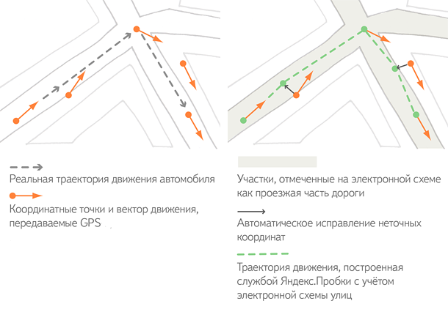

In order to properly recreate the picture of traffic congestion, it is necessary to check whether the situation corresponds to the track on your site. Users of mobile Yandex.Maps can sometimes stop or slow down the movement is not due to the traffic jams, and, for example, to buy something at a kiosk or unobtrusive not miss a turn. And if by free riding several cars with mobile devices, this track will be deselected algorithm because it does not reflect the actual workload of the site. Therefore, the more people are in service, the more precise information about the traffic situation.

After combining proven track algorithm analyzes them and exposes the "green", "yellow" and "red" assessment of the relevant sections of roads.

**Combining data**

Further there is aggregation - the process of combining information. Every two minutes aggregator collects, like a mosaic, the information received from users of mobile Yandex.Maps in one scheme. This pattern is drawn on a layer of "Jam" Yandex.Maps - and in the mobile application and web service.

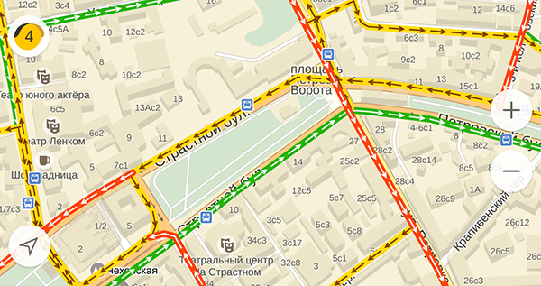

**Scale of points**

In Moscow, St. Petersburg and other major cities Yandeks.Probki service assesses the situation on the 10-point scale (where 0 points - the free movement and 10 points - the city of "costs"). With this assessment, drivers can quickly figure out approximately how much time they will lose in traffic jams. For example, if the average score in Kiev is seven, the road takes about two times longer than in free motion.

Scale scores configured differently for each of the cities that in Moscow - a glitch in another city - has a serious traffic jam. For example, in St. Petersburg, with six points driver to lose about the same time as even at five in Moscow.

Points are calculated as follows. In the streets of every city in advance compiled routes, including the main highways and avenues. For each route there is a reference time during which it is possible to drive on the open road without breaking the rules. After assessing the overall workload of the city aggregator program calculates how many different real time by reference. On the basis of the difference on all routes and the calculated load in points.